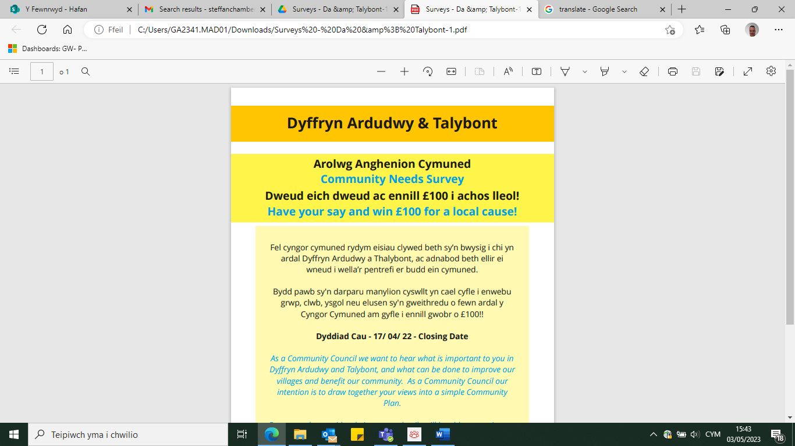

**Fel cyngor cymuned rydym eisiau clywed beth sy’n bwysig i chi yn  ardal Dyffryn Ardudwy a Thalybont, ac adnabod beth ellir ei  wneud i wella’r pentrefi er budd ein cymuned. Bydd pawb sy'n darparu manylion cyswllt yn cael cyfle i enwebu  grwp, clwb, ysgol neu elusen sy'n gweithredu o fewn ardal y  Cyngor Cymuned am gyfle i ennill gwobr o £100!**

**Os ydych yn dewis llenwi yr arolwg ar ffurf bapur a fedrwch chi dychwelyd yr holiadur yn nol ir adeilad a gasglwyd Fox’s of Dyffryn Neu Spar / London House Stores**

**Fel arall fedrwch gwblhau yr holiadur dros y we ar:**



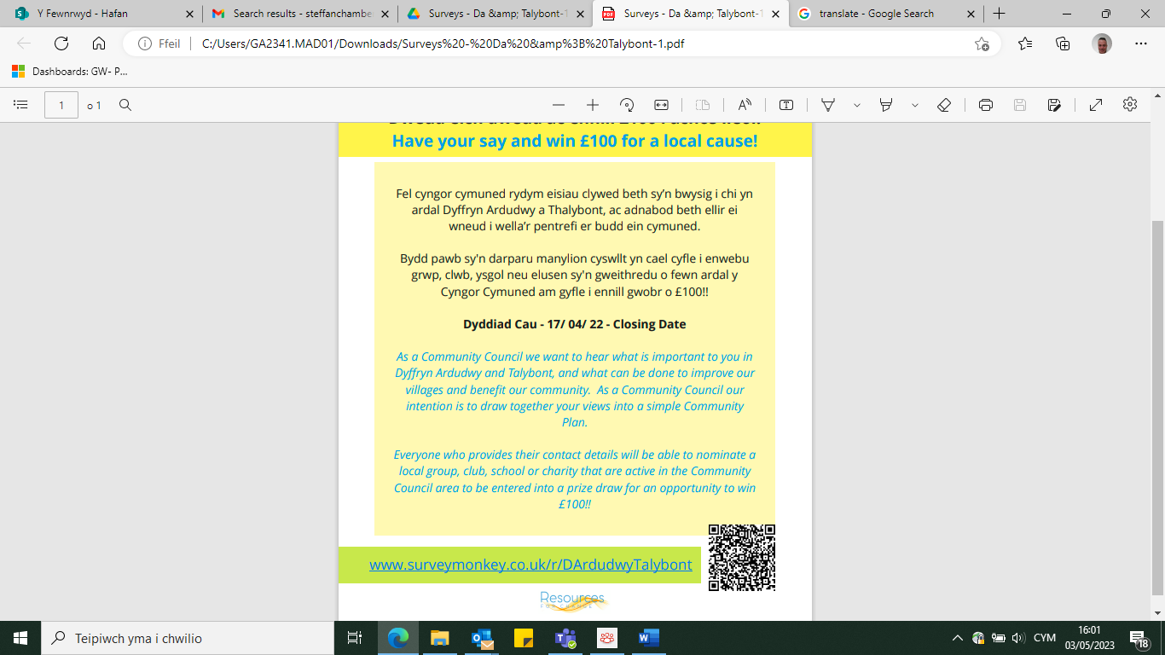

**As a community council we want to hear what is important to you in the Dyffryn Ardudwy and Talybont area, and identify what can be done to improve the villages for the benefit of our community. Everyone who provides contact details will have the opportunity to nominate a group, club, school or charity operating within the Community Council area for a chance to win a £100 prize!**

**If you have chosen to complete a paper survey, please return to the building you collected it from Fox Well's Store Or Spar / London House**

**Alternatively, you can complete the questionnaire online:**

